Assignment4

Bootstrap 1

Output:

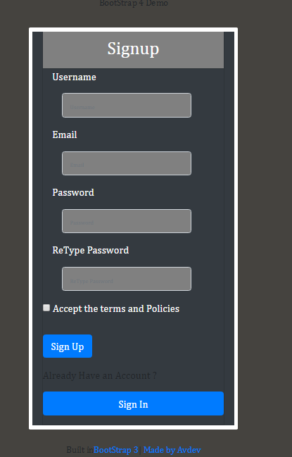

Code Snippet

<!DOCTYPE html>

<html xmlns="http://www.w3.org/1999/xhtml">

<head>

<title></title>

<meta name="viewport" content="width=device-width, initial-scale=1">

<link href="Bootstrap/css/bootstrap.css" rel="stylesheet" />

<script src="Bootstrap/js/bootstrap.min.js"></script>

<script src="jquery/jquery-3.3.1.js"></script>

<style>

.panel-primary {

border-color: #bce8f1;

}

.panel-primary > .panel-heading {

background: #bce8f1;

}

.bg-gray {

background-color: gray;

}

.panel-primary > .panel-body {

background-color: #EDEDED;

}

body, html {

height: 80%;

background-repeat: no-repeat;

background-color: #45433f;

font-family: Cambria, sans-serif;

}

.main {

margin-top: 70px;

}

hr {

width: 10%;

color: #fff;

}

.form-group {

margin-bottom: 15px;

}

label {

margin-bottom: 15px;

color:white;

}

input,

input::-webkit-input-placeholder {

font-size: 9px;

color:white;

border-radius:2px;

}

.main-login {

background-color: #fff;

/\* shadows and rounded borders \*/

-moz-border-radius: 2px;

-webkit-border-radius: 2px;

border-radius: 2px;

}

.main-center {

margin-top: 5px;

margin: 0 auto;

max-width: 330px;

padding: 6px 6px 6px 6px;

}

.login-button {

margin-top: 5px;

background-color:gray;

}

footer {

background-color: #777;

padding: 10px;

text-align: center;

color: white;

}

header {

background-color: #666;

padding: 30px;

text-align: center;

font-size: 35px;

color: white;

}

h4 {

font-size: 14px;

}

</style>

</head>

<body>

<div class="container">

<div class="row col-lg-12">

<div class="col-lg-6 col-md-6 col-sd-10 col-lg-offset-3 col-md-offset-3 align-content-center">

<div class="panel panel-heading col-offset-3">

<h4 class="text-center">BootStrap 4 Demo</h4>

</div>

<br />

<div class="panel-body">

<div class="main-login main-center">

<form class="form-horizontal bg-dark col-lg-12 col-lg-offset-12" method="post" action="#">

<div class="card bg-dark rounded-0">

<div class="card-header p-0">

<div class="bg-gray text-white text-center py-2">

<h3>Signup</h3>

</div>

</div>

<div class="form-group col-lg-12">

<label for="username" class="cols-lg-12 control-label">Username</label>

<div class="col-lg-11 col-lg-offset-1">

<div class="input-group">

<input type="text" class="form-control bg-gray" name="username" id="username" placeholder="Username" />

</div>

</div>

</div>

<div class="form-group col-lg-12">

<label for="email" class="cols-lg-12 control-label">Email</label>

<div class="col-lg-11 col-lg-offset-1">

<div class="input-group">

<input type="text" class="form-control bg-gray" name="email" id="email" placeholder="Email" />

</div>

</div>

</div>

<div class="form-group col-lg-12">

<label for="password" class="cols-lg-12 control-label">Password</label>

<div class="col-lg-11 col-lg-offset-1">

<div class="input-group">

<input type="password" class="form-control bg-gray" name="password" id="password" placeholder="Password" />

</div>

</div>

</div>

<div class="form-group col-lg-12">

<label for="confirm" class="cols-lg-12 control-label">ReType Password</label>

<div class="col-lg-11 col-lg-offset-1">

<div class="input-group">

<input type="password" class="form-control bg-gray" name="confirm" id="confirm" placeholder="ReType Password" />

</div>

</div>

</div>

<div class="form-group">

<div class="col-xs-9 col-xs-offset-3">

<div class="checkbox">

<label>

<input type="checkbox" name="agree" value="agree" /> Accept the terms and Policies

</label>

</div>

</div>

</div>

<div class="form-group ">

<button type="button" class="btn btn-primary btn-xs">Sign Up</button>

</div>

<div class="form-group">

<span class="align-content-lg-center">Already Have an Account ?</span>

</div>

<div class="form-group ">

<button type="button" class="btn btn-primary btn-xs btn-block">Sign In</button>

</div>

</div>

</form>

</div>

</div>

<br />

<div class="panel panel-primary col-offset-3">

<h4 class="text-center"><span>Built in</span><a href="http://boostrap.com">BootStrap 3</a>| <a href="https://google.com">Made by Avdev</a></h4>

</div>

</div>

</div>

</div>

</body>

</html>